ExpenseTrackerApp Test
===========================================
Expense Tracker Test Data
Tester: Julien Morales
Date: July 11 2026
===========================================

Test 1
Description: Inputting Username and Password INCORRECTLY
Expectation: Incorrect, N/A Attempts left and locked out.
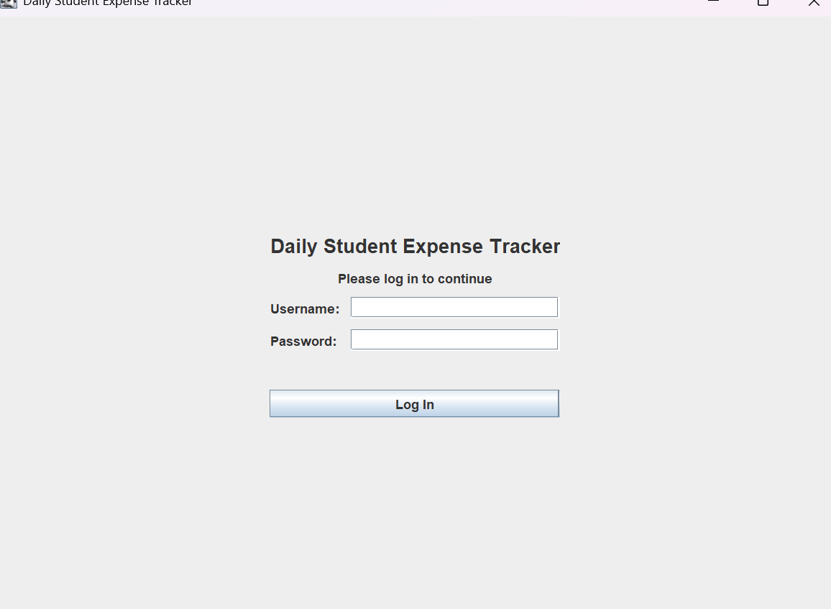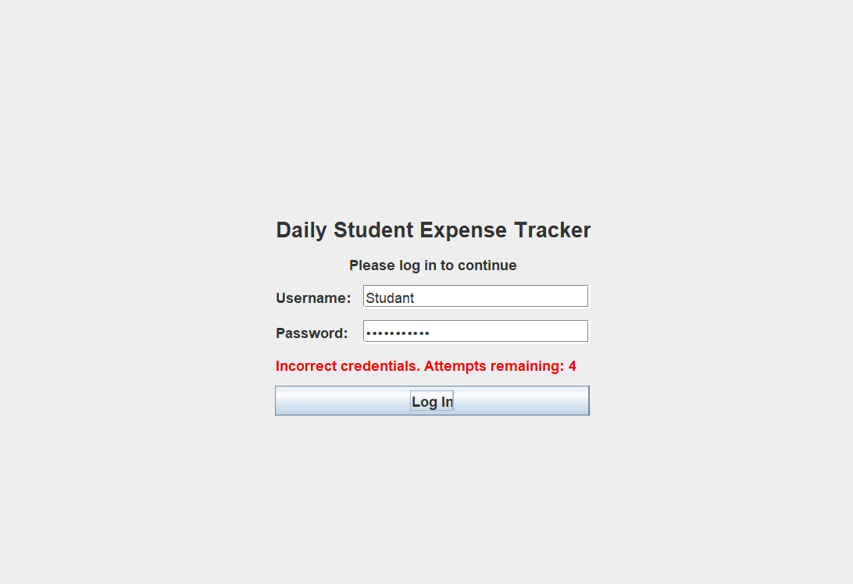

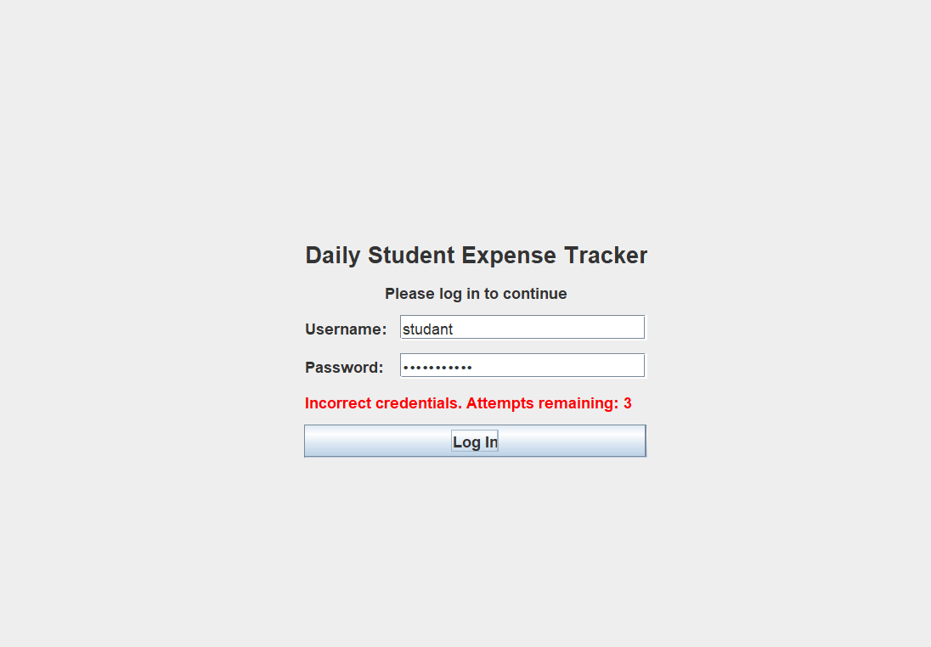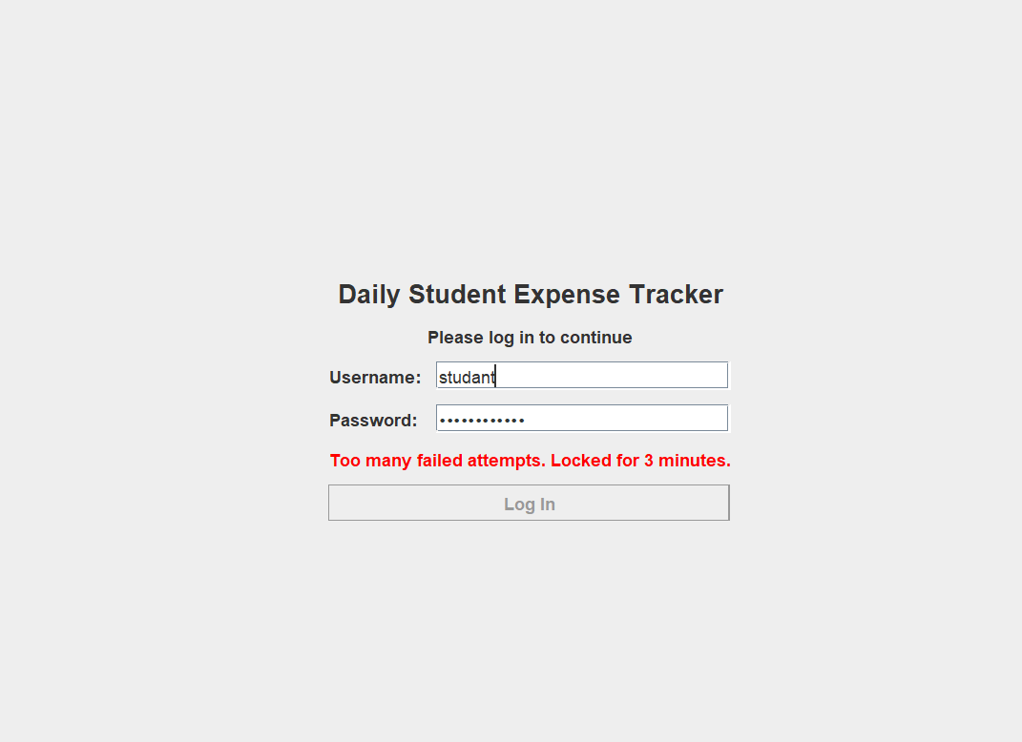
STATUS: PASS, although when leaving the app, timer completely resets, making the timer OBSOLETE
==========================================
Test 2
Description: Inputting CORRECT Username and Password.
Expectation: After putting the correct credentials it logs me in and shows me my DAILY REMINDER if I tracked my expenses today.
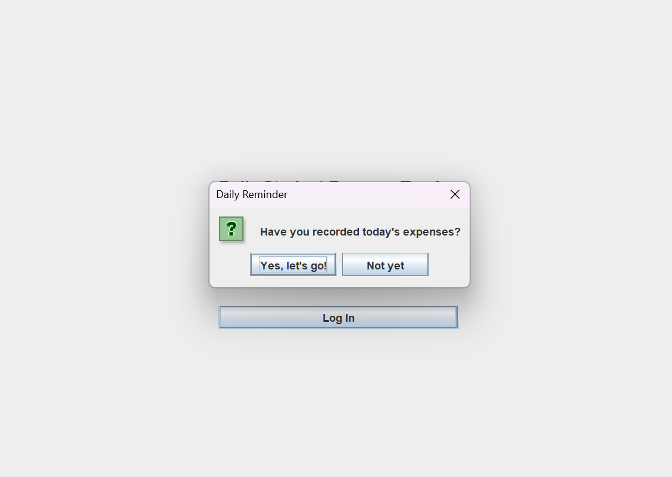
STATUS: PASS
===========================================
Test 3
Description: Testing if options “Yes, Lets go!” and “Not yet” completes the correct actions
Expectation: Clicking YES will take us to the main menu, clicking NO will take us to “ADD NEW TRANSACTION”
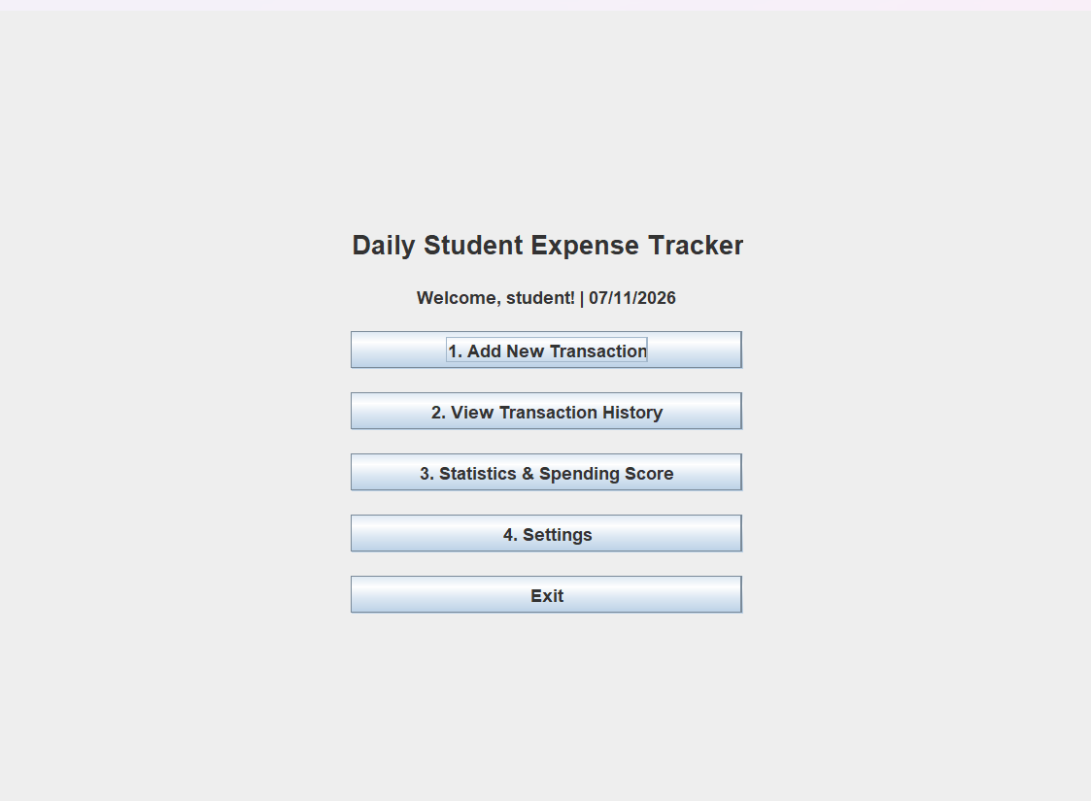
STATUS: FAILED
Explanation: Clicking YES takes us to main menu: PASS.
Clicking NO takes us to Add New Transaction: FAIL
If this isn’t coded into program, then actions have been passed.

============================================
Test 4
Description: Testing if switching between options and panels constantly starts lagging program after a while
Expectation: System will remain running flawlessly
NO IMAGE FOR THIS ONE
STATUS: PASS
=========================================================================
Test 5
Description: Going into “Add new transaction” and seeing if dropdowns work as intended.
Expectation: Swapping from “Income” to “expenses” will change the other dropdown options below
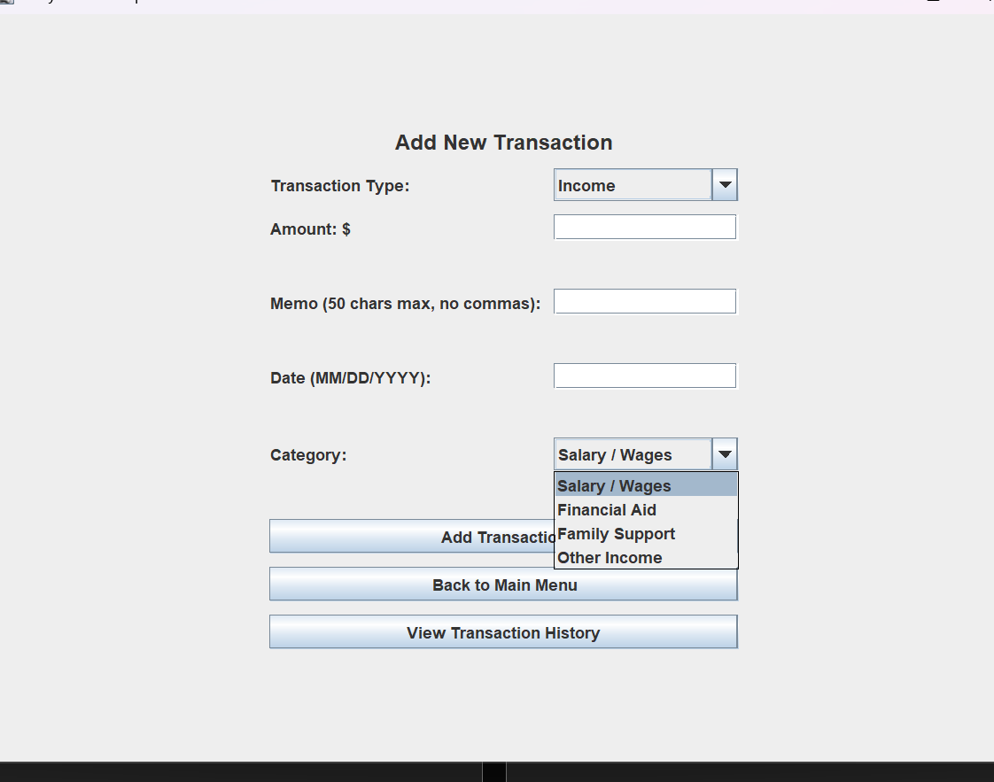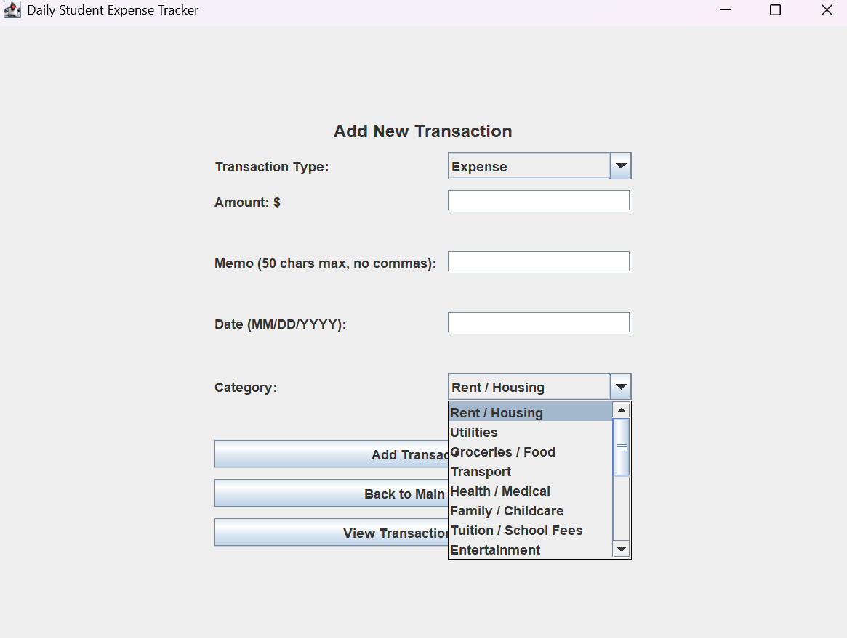
STATUS: PASS
===============================================================

Test 6
Description: Testing if “Add New Transaction” works as intended and if it can handle multiple ERROR messages.
Expectation: If date is input INCORRECTLY, will get an error message. IF AMMOUNT is an invalid number, give error message. IF MEMO exceeds limit, give error message. 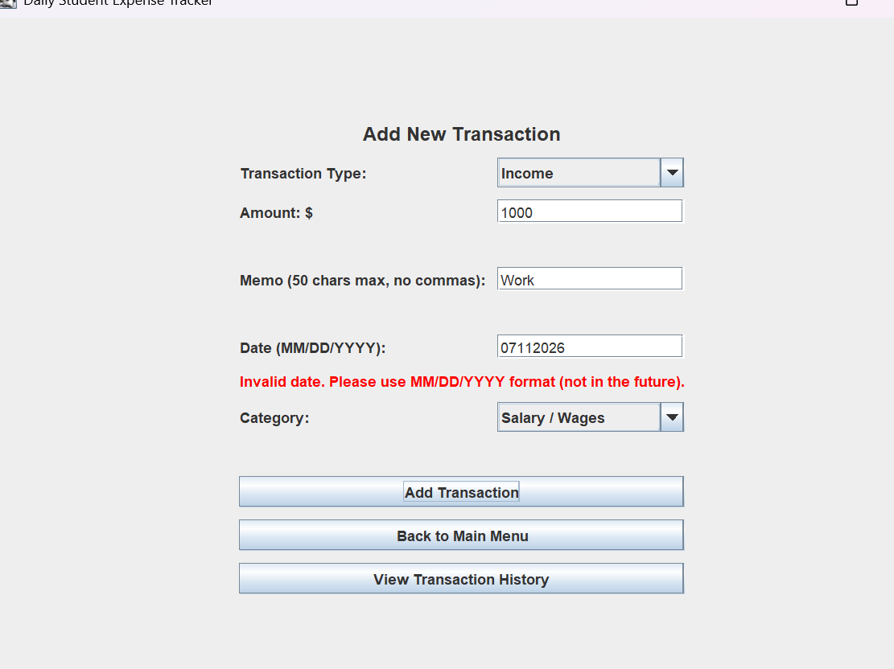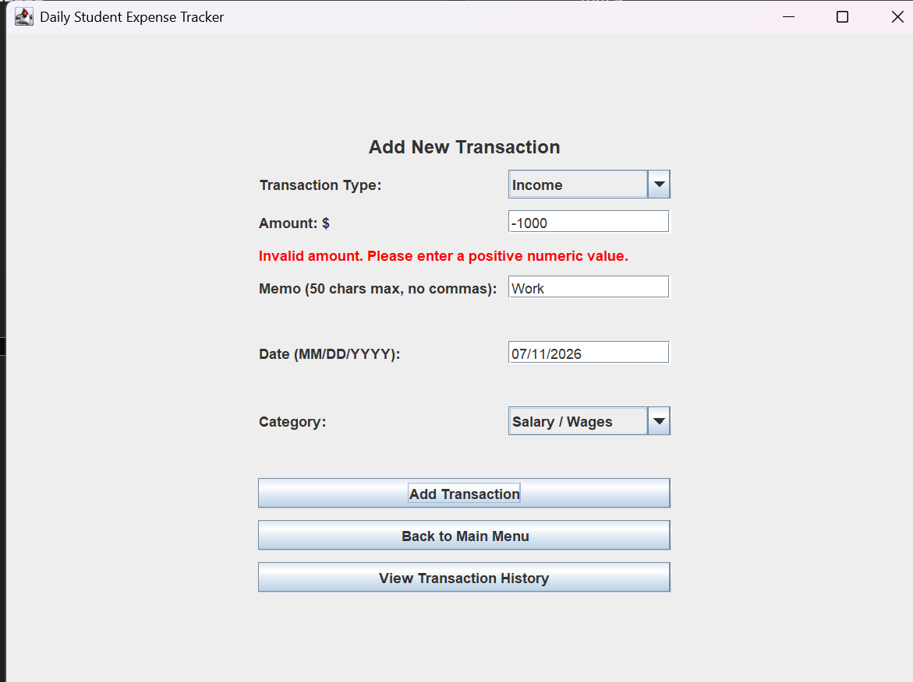
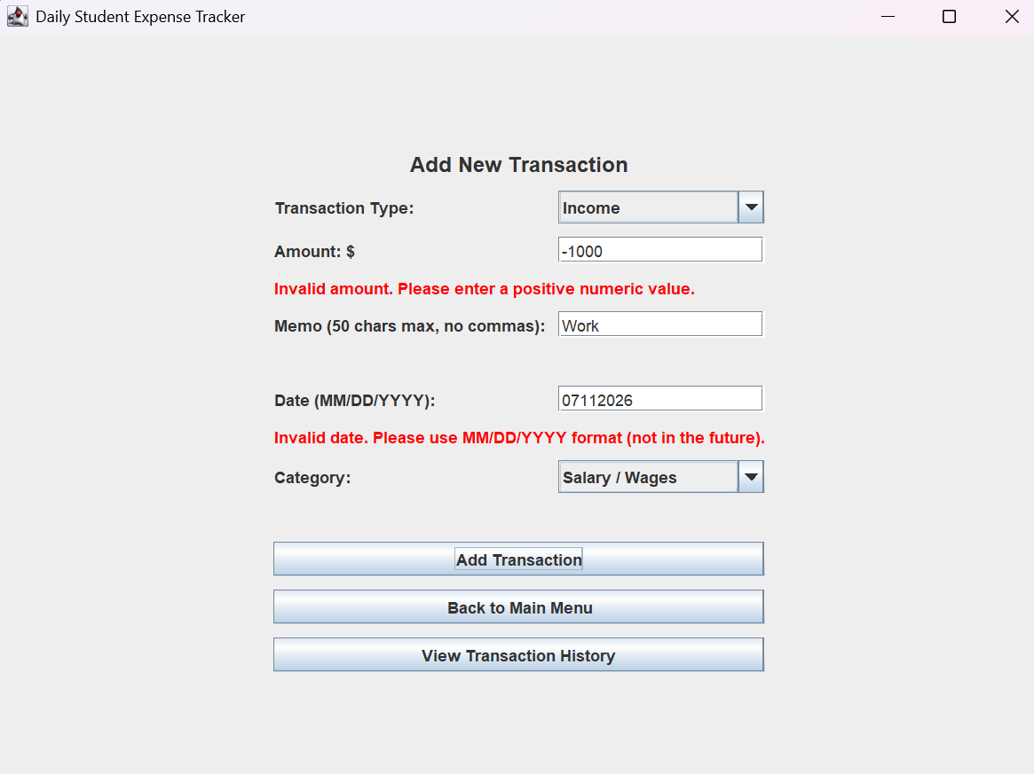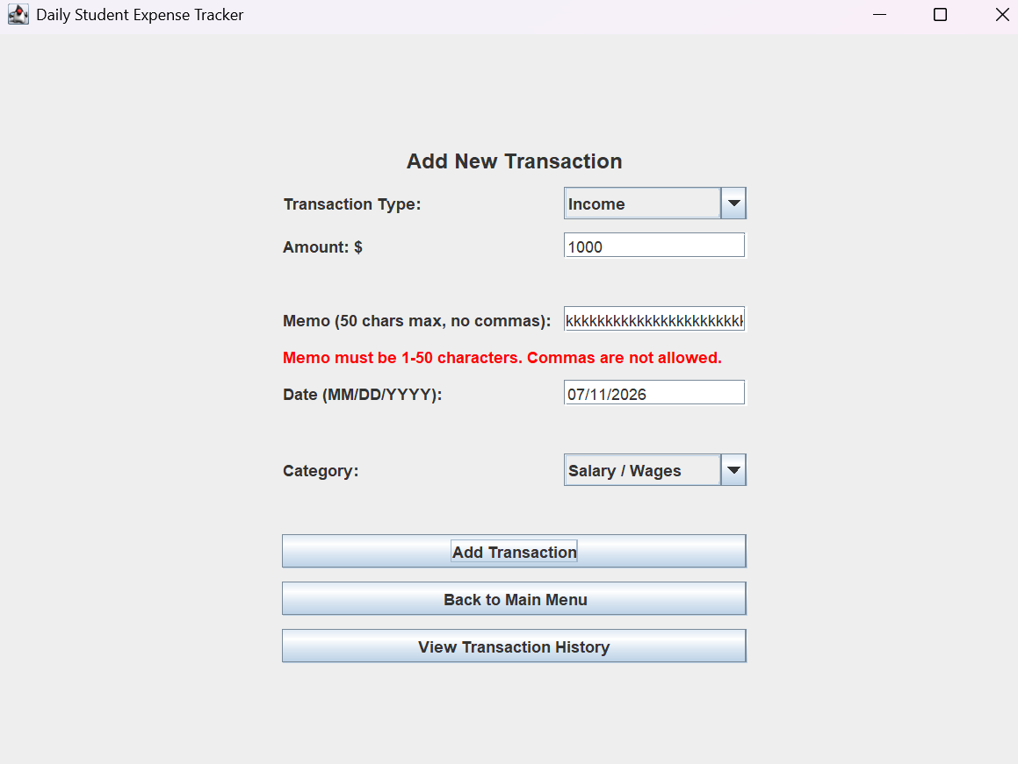
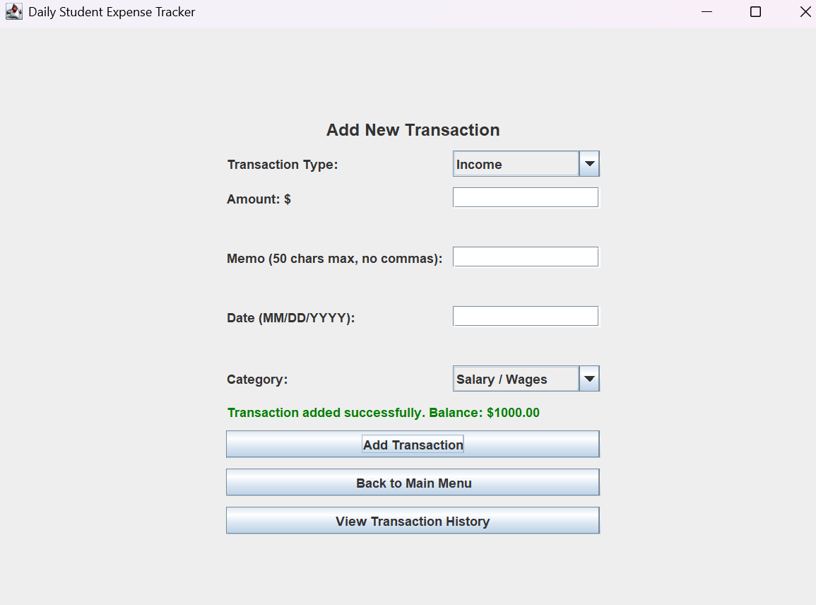
STATUS: PASS
=================================================================
Test 7
Description: Testing if everything appears correctly in “View Transaction History” and if OLD transactions appear and if “select date range” works too.
Expectation: Everything will appear in a list, ranking transactions ID starting from 1 down listing its TYPE, DATE, CATEGORY, MEMO, and AMOUNT.
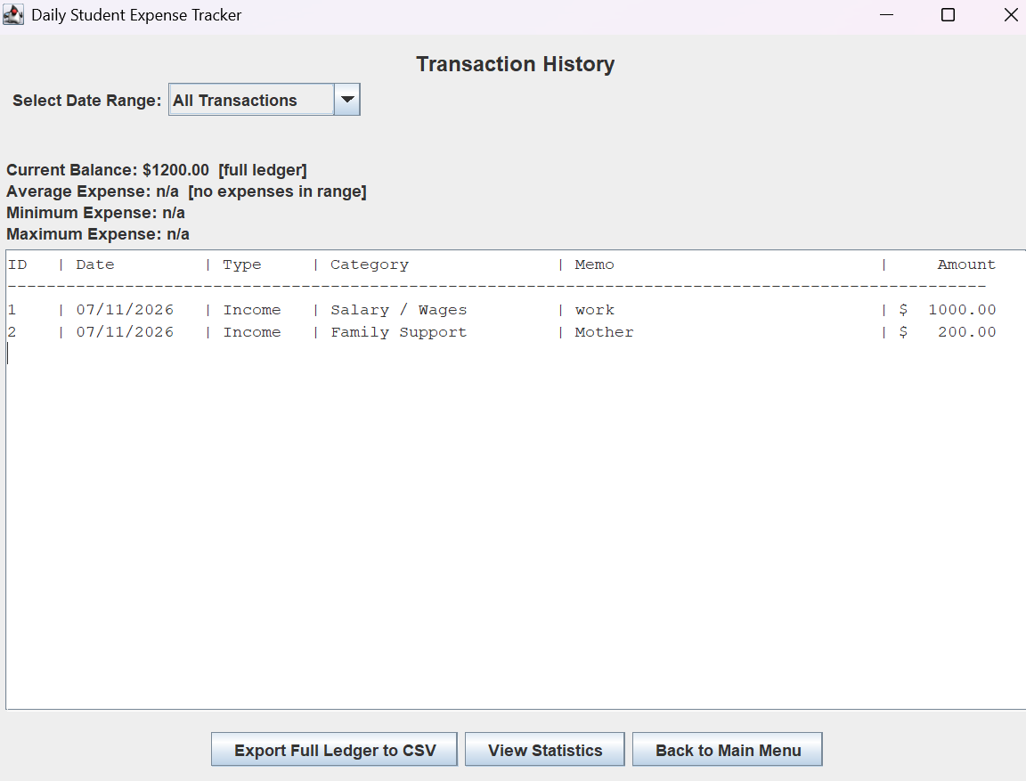
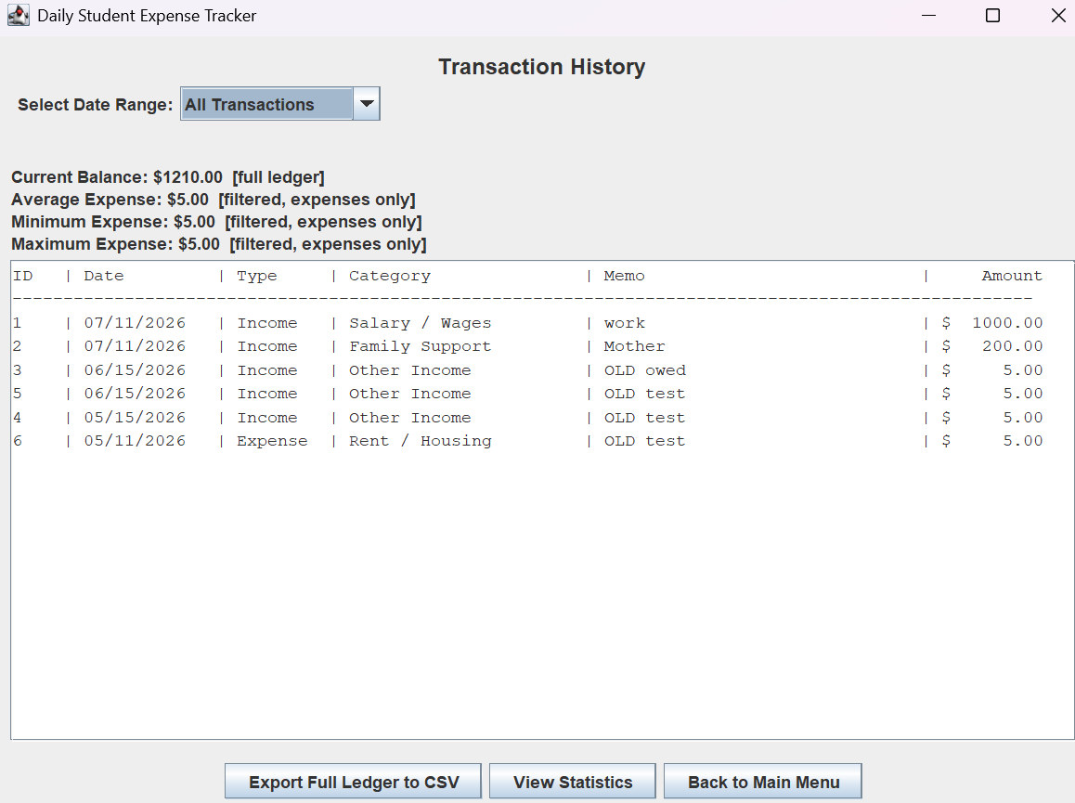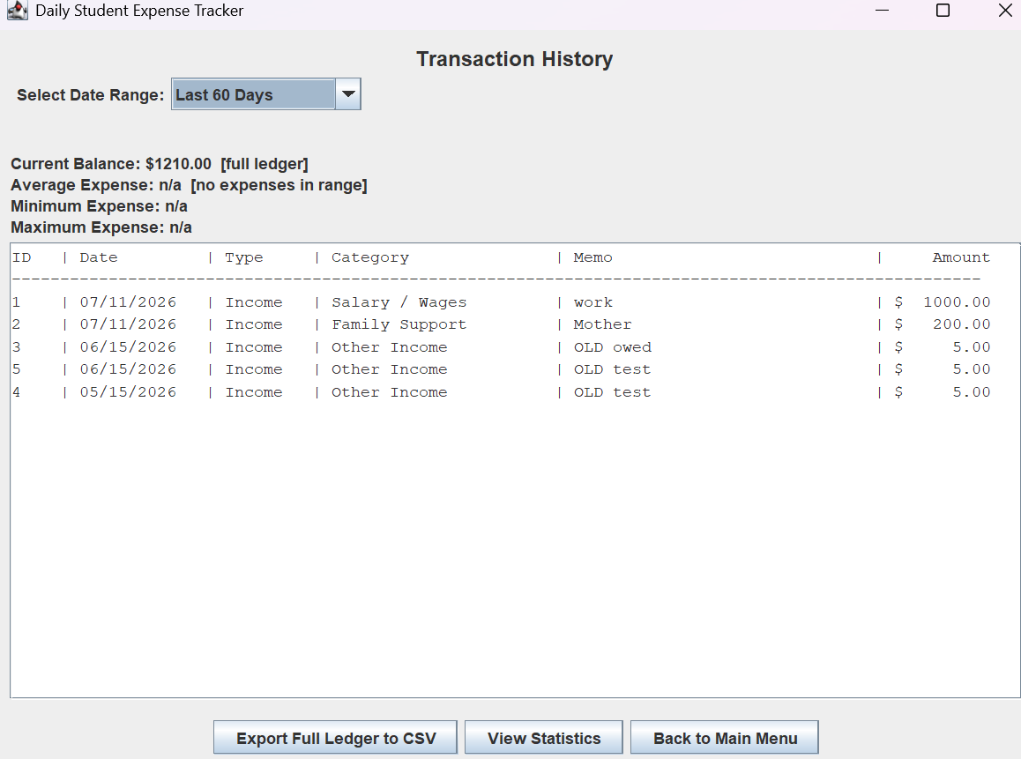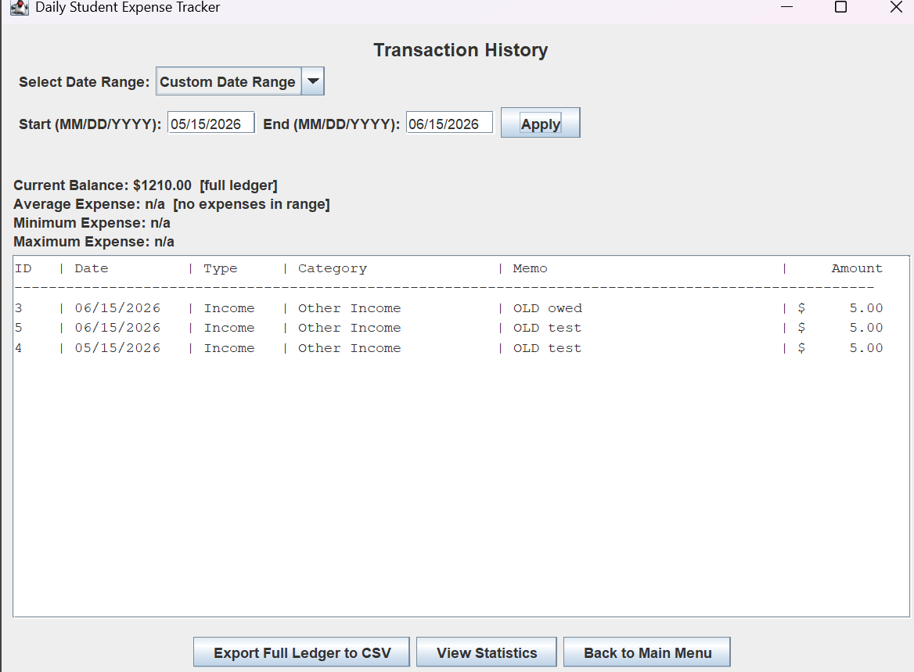
Status: PASS
=============================================================

Test 8
Description: Testing if “statistics and spending score” work as intended
Expectation: Expect to see Current balance, Total income, Total expenses, average, min, and max expenses. Since iv spent NO MONEY, I expect to see 100 percent spending score and 100% of remaining income retained.
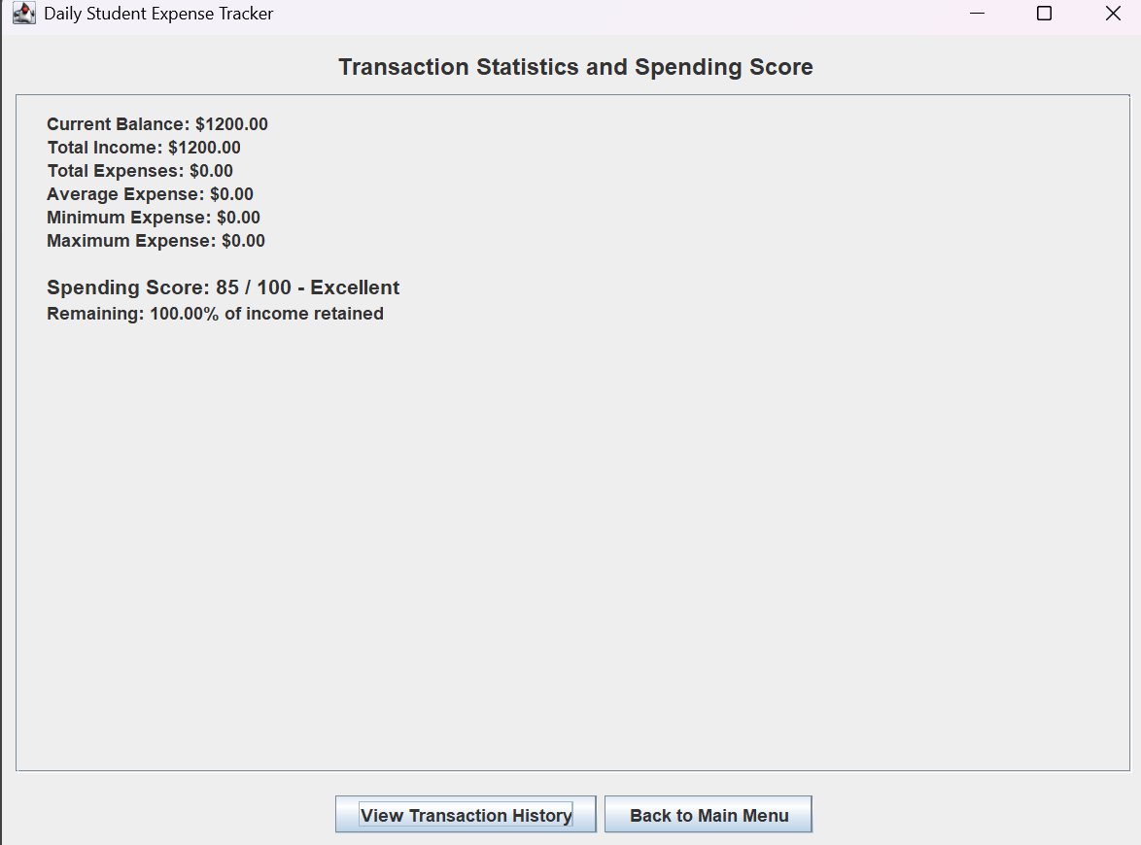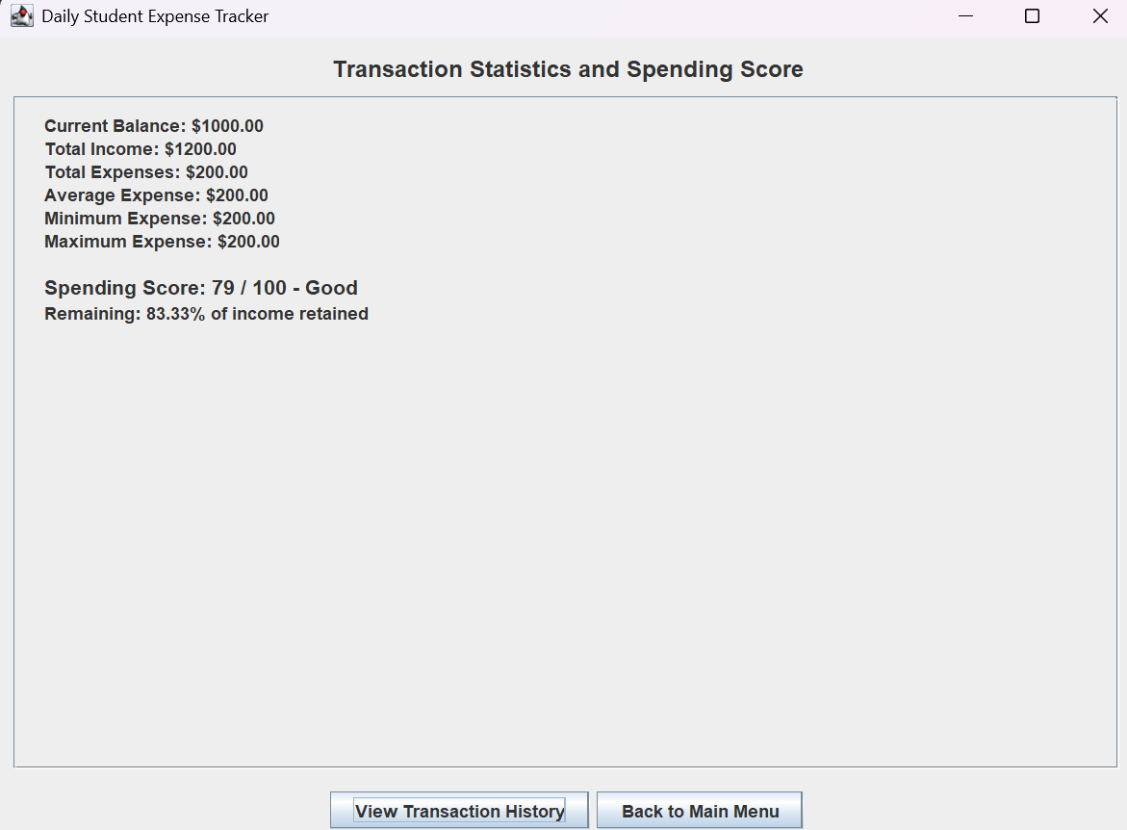
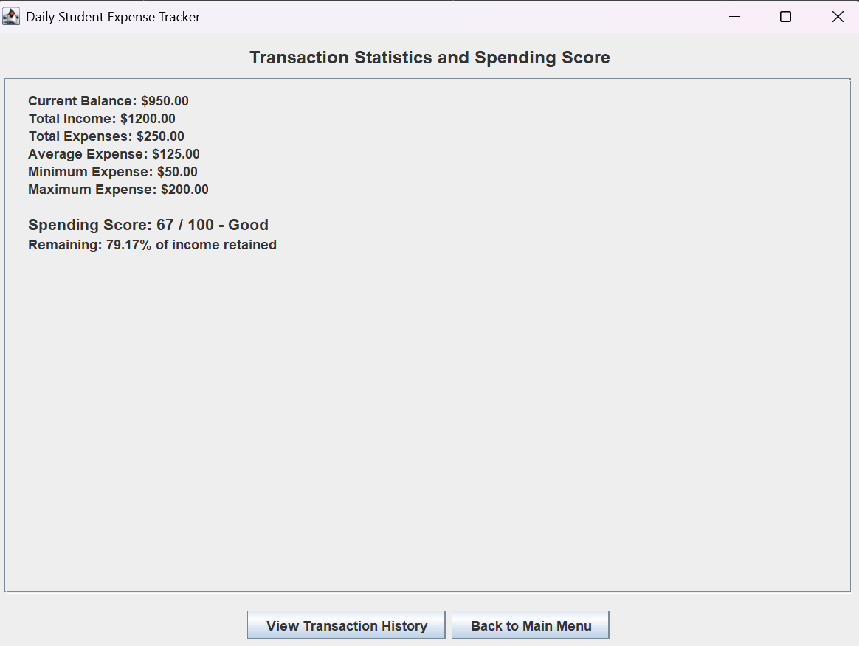 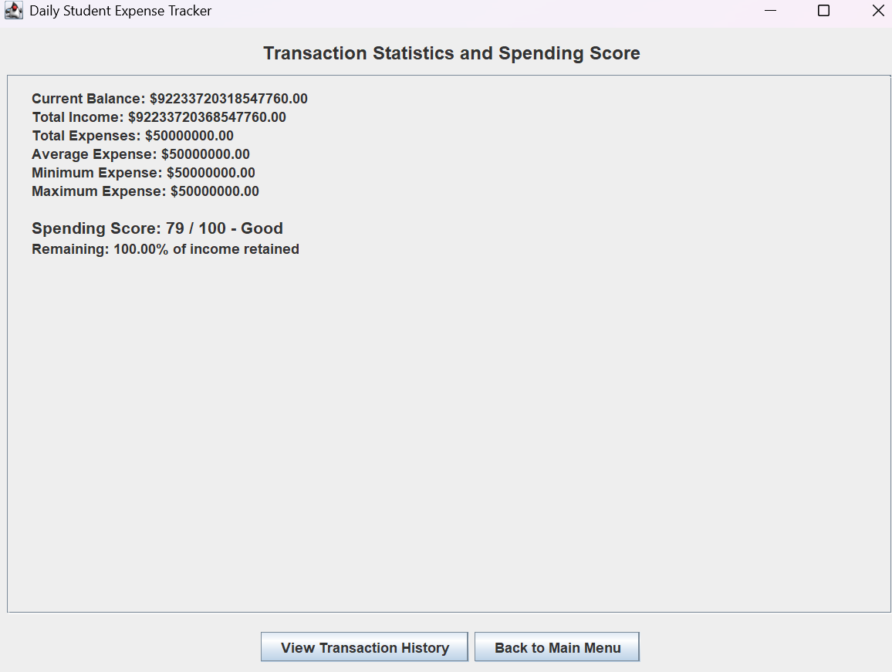
STATUS: PASS but needs work >>>>>
explanation: I am unsure wether the spending score is accurate. In the FIRST photo iv spent no money yet it says my spending score is 85? But 100 percent of my money was retained. In the SECOND photo I spent 200 and it did calucate percentage retained correctly but spending score went from 85 to 79. In the THIRD photo, I spent another 50 to test if it shows min and max and my score went down to 67. IF ITS SUPPOSE TO WORK LIKE THIS, then it PASSES.
In the LAST photo, I put in a transaction of 1000000000000000000000 INCOMING, and made an expense of 5000000. IT calucated my spending score but FAILED at the percentage retained, it still says 100 percent, even tho I spent 50000000. Maybe its cause its such a small ammount compared to the original number.
=========================================================================

Test 9
Description: testing if settings work as intended:
Expectation: When opening settings we get 3 options including show dialy reminder. clicking clear all transactions, Yes or No pops up. When clicking no NOTHING HAPPENS. When clicking yes, it clears all transactions.
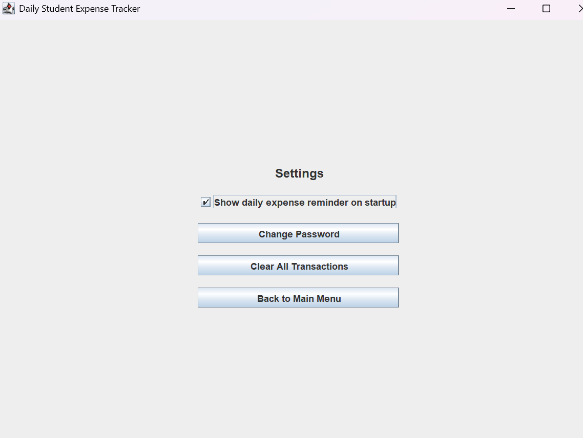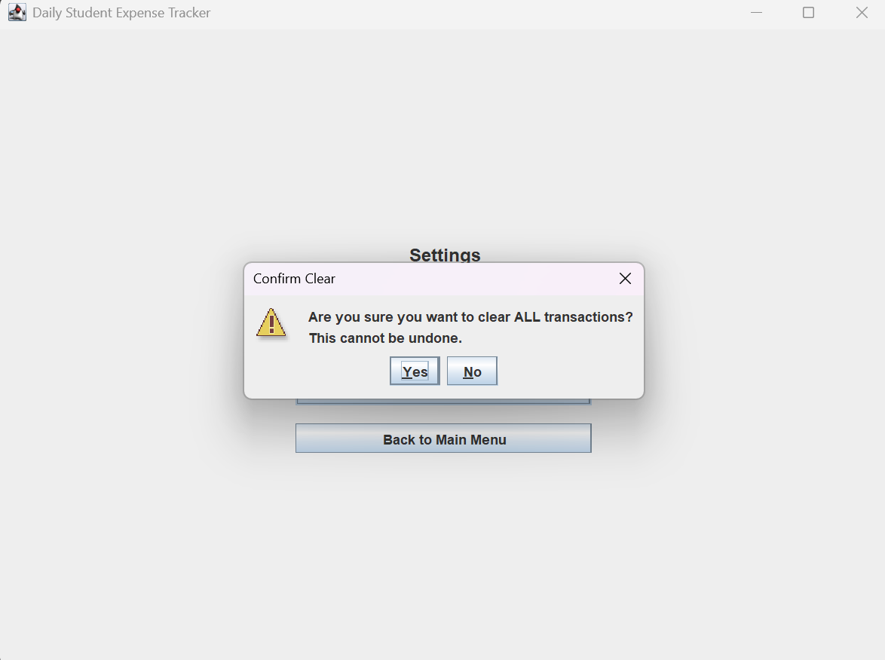

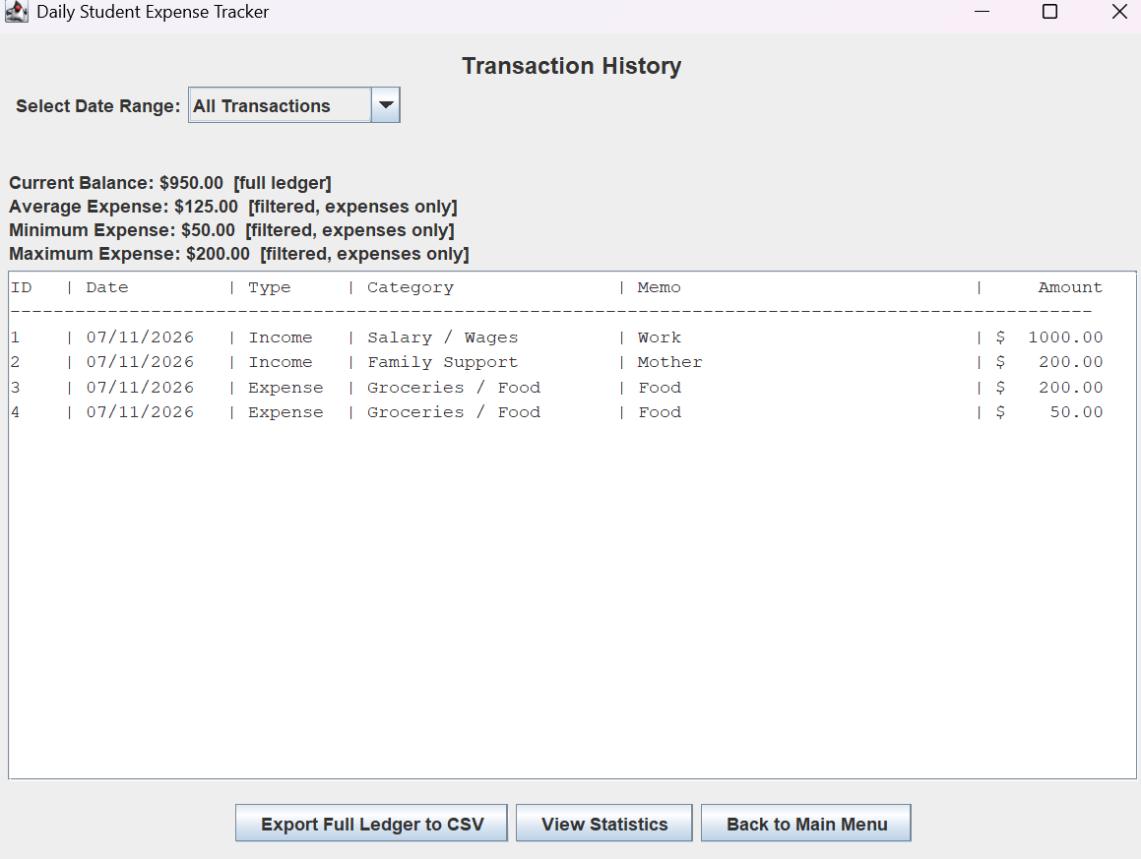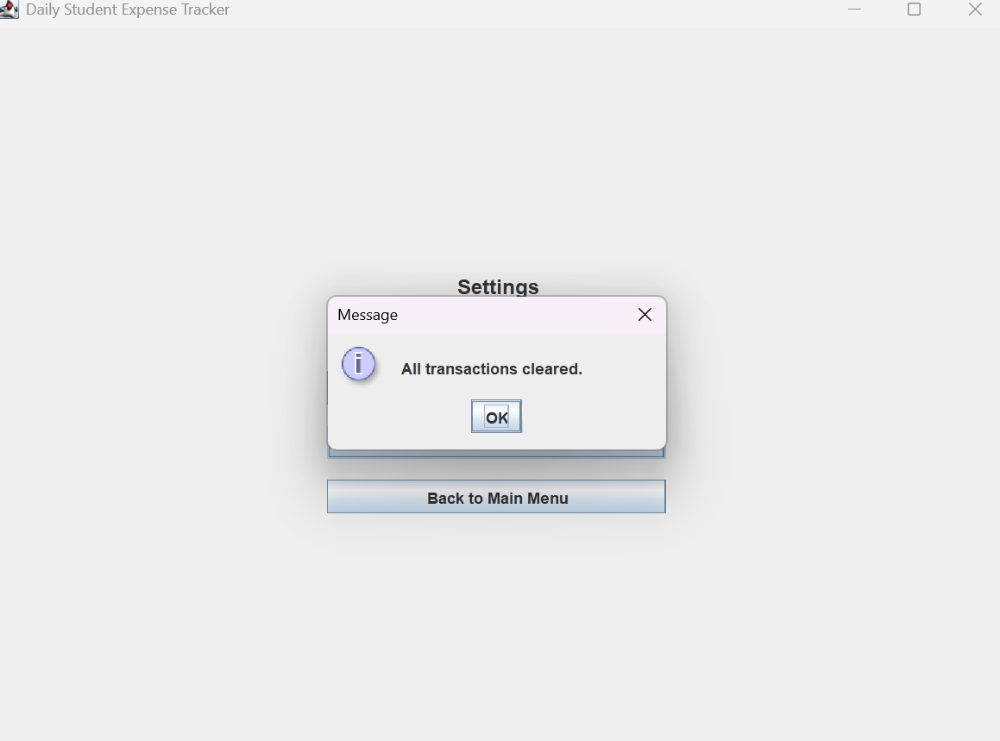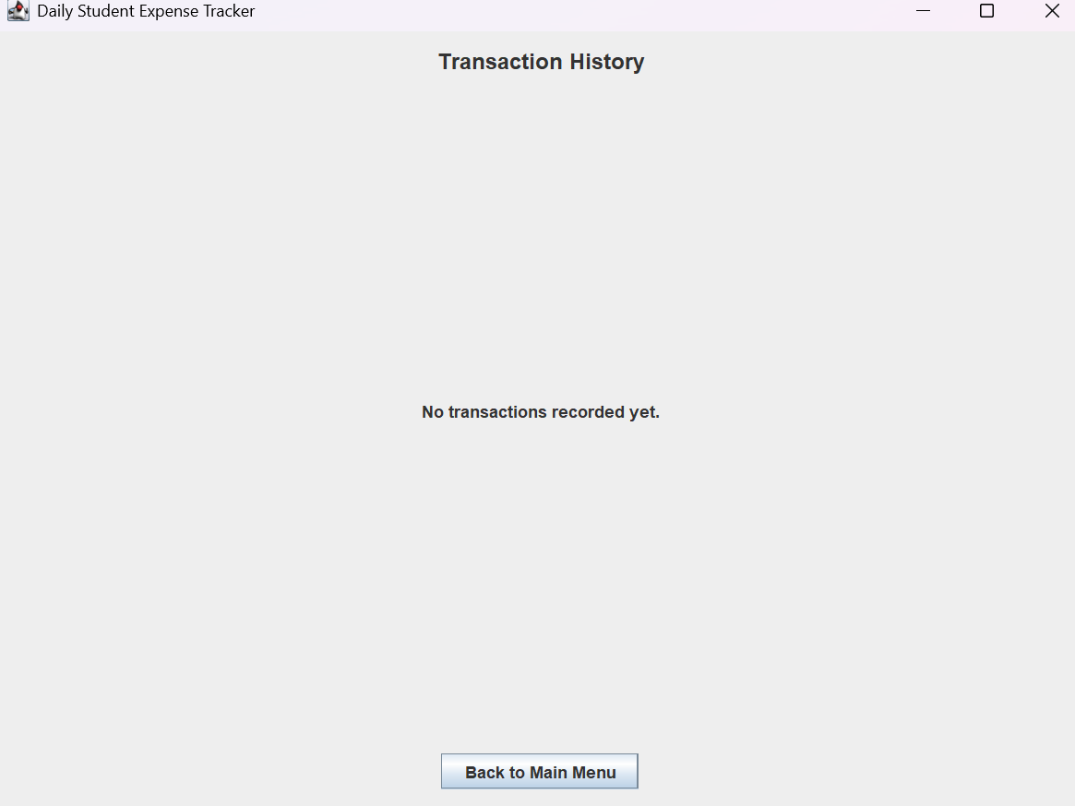
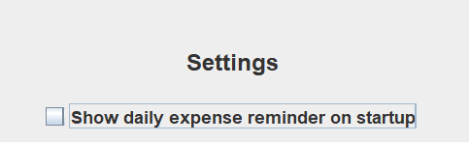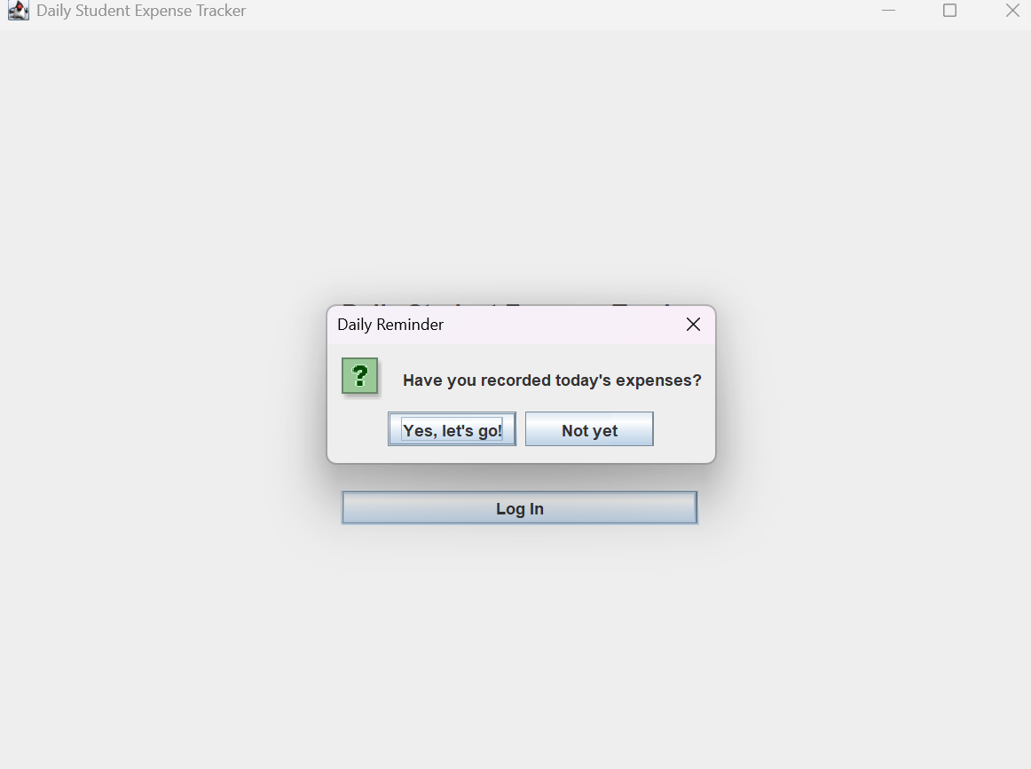
STATUS: PASSED Except for daily reminder option
Explanation: When toggling “Show daily expense reminder on startup” OFF. IT still pops up on startup. This is prob the same issue u were mentioned about the password staying the same regardless if us switching. (REASON WHY I DIDN’T TEST PASSWORD CHANGE)

